JS runtime (like V8) can do only one thing at a time

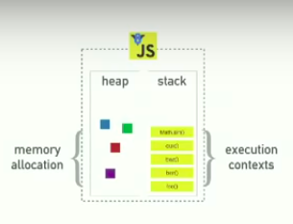

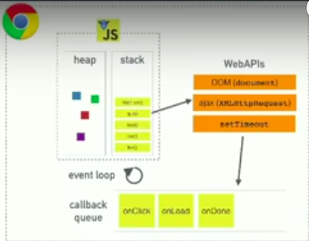

The previous image is exactly the node js structure, but replacing WebAPIs with C++ APIs

Single threaded = Single call stack = one thing at a time

Blocking → Things that are slow and blocking in call stack (image processing – loop over millions of records – slow network request)

The reason we can do things concurrently in the browser is that the browser is more than just the runtime.

When an asynchronous code is called on the stack, it is deferred to the webapis to handle it.

Event loop takes the callback from webapis, waits until the call stack is empty and then pushes the callback into it.

This explains why we cannot use values of the returned callback after calling the asynchronous code, as it will be the last code to be executed on the stack. We have to handle it inside the callback when it returns.

This applies on (XHR – set timeout – buttons events ….)

This also can explain why setTimeOut is not running exactly after the time it is supposed to run, as the callback is queued until callbacks before it are processed after the stack is empty.

- Callbacks can be any function that another function calls
- or it can be an asynchronous callback

Browser cannot do a render (which is done normally every 16 ms) if there is code on the stack, like callbacks. Rendering has priority over callbacks. This explains why people says: “ don’t put slow things on the stack as it blocks rendering”.

https://www.youtube.com/watch?v=8aGhZQkoFbQ&feature=youtu.be&fbclid=IwAR0rfvW1ZKtytAhKLwRSPOb7BW2uX7YmjPsjCQm_C2kDV5bqRH8OY43SS10

from minute 13

